PRACTICAL NO. 3
AIM: Configure VLAN using Cisco Packet Tracer.
THEORY:
Introduction to VLAN
A Virtual Local Area Network (VLAN) is a logical grouping of devices within a network, regardless of their physical location. VLANs allow a single physical network to be divided into multiple logical networks, improving performance, security, and network management.
In traditional LANs, all devices are part of the same broadcast domain. VLANs break this large broadcast domain into smaller, manageable segments.

Need for VLAN
VLANs are used to:
- Reduce network congestion by limiting broadcast traffic
- Improve security by isolating sensitive departments
- Organize users logically (e.g., HR, Admin, Students)
- Improve network efficiency and performance
- Simplify network management

Working of VLAN
- Each VLAN acts as a separate broadcast domain
- Devices in the same VLAN can communicate directly
- Devices in different VLANs cannot communicate without a router or Layer 3 switch
- VLANs are identified using VLAN IDs (1–4094)

Types of VLAN
- Default VLAN – VLAN 1 (all ports belong by default)
- Data VLAN – Used for user-generated traffic
- Management VLAN – Used for managing network devices
- Native VLAN – Used for untagged traffic on trunk ports

VLAN Configuration in Cisco Packet Tracer
In Cisco Packet Tracer, VLAN configuration involves:
- Creating VLANs on a switch
- Assigning switch ports to specific VLANs
- Verifying VLAN assignment
- Testing communication between devices
Basic Steps:
- Create VLANs using VLAN ID and name
- Assign switch ports to VLANs
- Connect end devices to respective ports
- Verify VLAN configuration using commands

Advantages of VLAN
- Enhanced network security
- Reduced broadcast traffic
- Better bandwidth utilization
- Logical grouping of users
- Scalable and flexible network design

Applications of VLAN
- Colleges and universities (Student, Faculty VLANs)
- Corporate offices (HR, Finance, IT departments)
- Hospitals (Admin, Doctors, Labs)
- Large enterprises and data centers

Features of VLAN (Virtual Local Area Network)
- Logical Network Segmentation
VLAN divides a physical network into multiple logical networks based on function, department, or application.
- Reduced Broadcast Traffic
Each VLAN forms its own broadcast domain, which reduces unnecessary broadcast messages and improves network performance.
- Improved Security
Devices in different VLANs are isolated from each other, preventing unauthorized access to sensitive data.
- Better Network Performance
By limiting broadcast traffic, VLANs help in efficient utilization of bandwidth.
- Flexibility and Scalability
Users can be moved between VLANs without changing physical connections, making network expansion easy.
- Centralized Network Management
VLANs allow easy monitoring, configuration, and troubleshooting of the network.

SCREENSHOT:
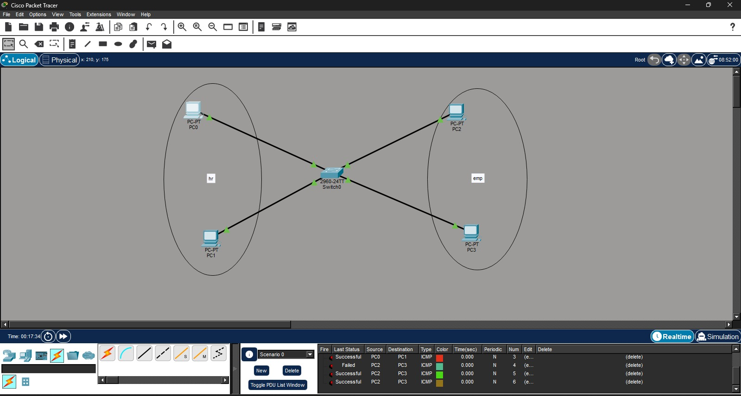
CONCLUSION: VLAN configuration is an essential networking concept that allows efficient segmentation of networks. By configuring VLANs in Cisco Packet Tracer, we can understand how logical network division improves security, performance, and manageability in modern computer networks.
Performance | Attendance | Viva | Total
/ 7 | / 3 | / 5 | /15

